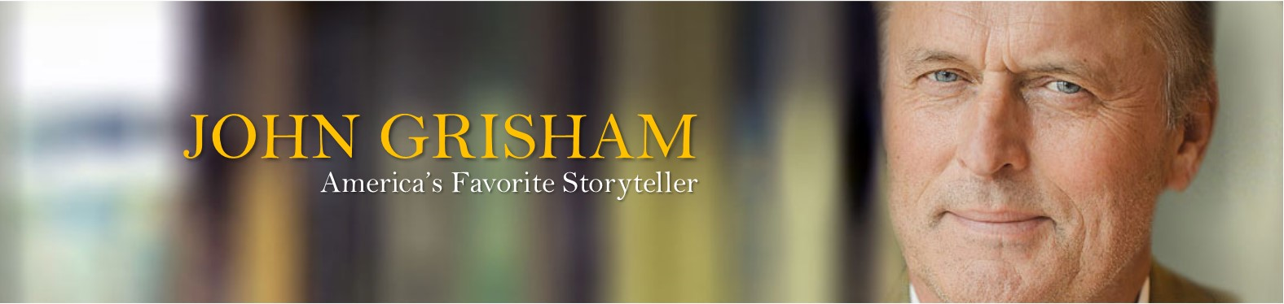

Live Every Dinner 2017
An Evening of Celebration & Inspiration
With Guest Speaker John Grisham, America’s Favorite Story Teller
Thursday, August 3, 2017 – Carmel Country Club, 5:00 – 8:00 PM
To Benefit
SPONSORSHIP OPPORTUNITIES
Thank you for your support. Sponsorship funding helps continue the Foundation’s mission of helping people with Amyotrophic Lateral Sclerosis (ALS) with FREE home care services, resources, caregiver training and more.

Exclusive Presenting Sponsor – $25,000
- Front and Center Seating for dinner for 9 guests, John Grisham seated at table
- Invitation to VIP cocktail reception with John Grisham for all guests with autographed book
- Plaque Presentation at event and opportunity for remarks by company representative
- Company Featured in video vignette shown during program including interview by company representative
- Signature cocktail at table
- Company logo and/or name prominently featured on front cover of event program
- Company logo and/or name prominently featured on event signage, event nametags, general public tickets and all instances where the name of the event is listed.
- Company logo and/or name prominently featured on event webpage and all social media posts and event pages
- 2-page spread in event program
- Mention in all press releases including quote by company representative
Legacy Circle Sponsor - $10,000 (4 available)
- Front row Seating for dinner for 10 guests
- Invitation to VIP cocktail reception and book signing with John Grisham for all guests with autographed book
- Signature cocktail at table for each guest
- Company logo and/or name prominently featured on event signage
- Company logo and/or name prominently featured on event webpage and all social media posts and event pages
- Full page ad in event program

Gift of Joy - $5,000
- 2nd tier seating for table of ten
- Company logo and/or name featured on event signage
- Company logo and/or name featured on event webpage and all social media posts and event pages
- 1/4-page ad in event program
- 4 entries to VIP Cocktail Reception with John Grisham
Gift of Love $2,500
- 3rd tier seating for table of ten
- Company logo and/or name listed on event webpage and all social media posts and event pages
- Company logo and/or name listed in event program
- 2 entries to VIP Cocktail Reception with John Grisham
Gift of Hope - $1,650
- General Seating for dinner at table for 10 guests
- Company Name listed in event program
Individual Tickets - $200 individual, $350 a pair
*Individual Donors that give $2,500 will receive entry for 2 guests to the VIP Cocktail Reception and book signing with John Grisham.
Please complete and return:

Sponsorship Selection: _____ Presenting Sponsor _____ Legacy Sponsor _____ Joy_____Love_____Hope

Individual Tickets: ____ Individual Ticket ____ # of Pairs of Tickets

Individual/Organization/Company Name: ____________________________________________________
Contact Name: __________________________ Web Address: ___________________________________ Mailing Address: ________________________________________________________________________
Phone: ____________________________________ Email: ______________________________________

Amount Enclosed: $___________

___ Please send me an invoice

Please Return To:
The Joe Martin ALS Foundation/Live Every Day Dinner
100 N. Tryon Street, Suite 3420, Charlotte, NC 28202
www.joemartinalsfoundation.org
Contact Sarah Hayden, Director of Development for questions and further information
Sarahhayden@joemartinalsfoundation.org, 704-332-1929

